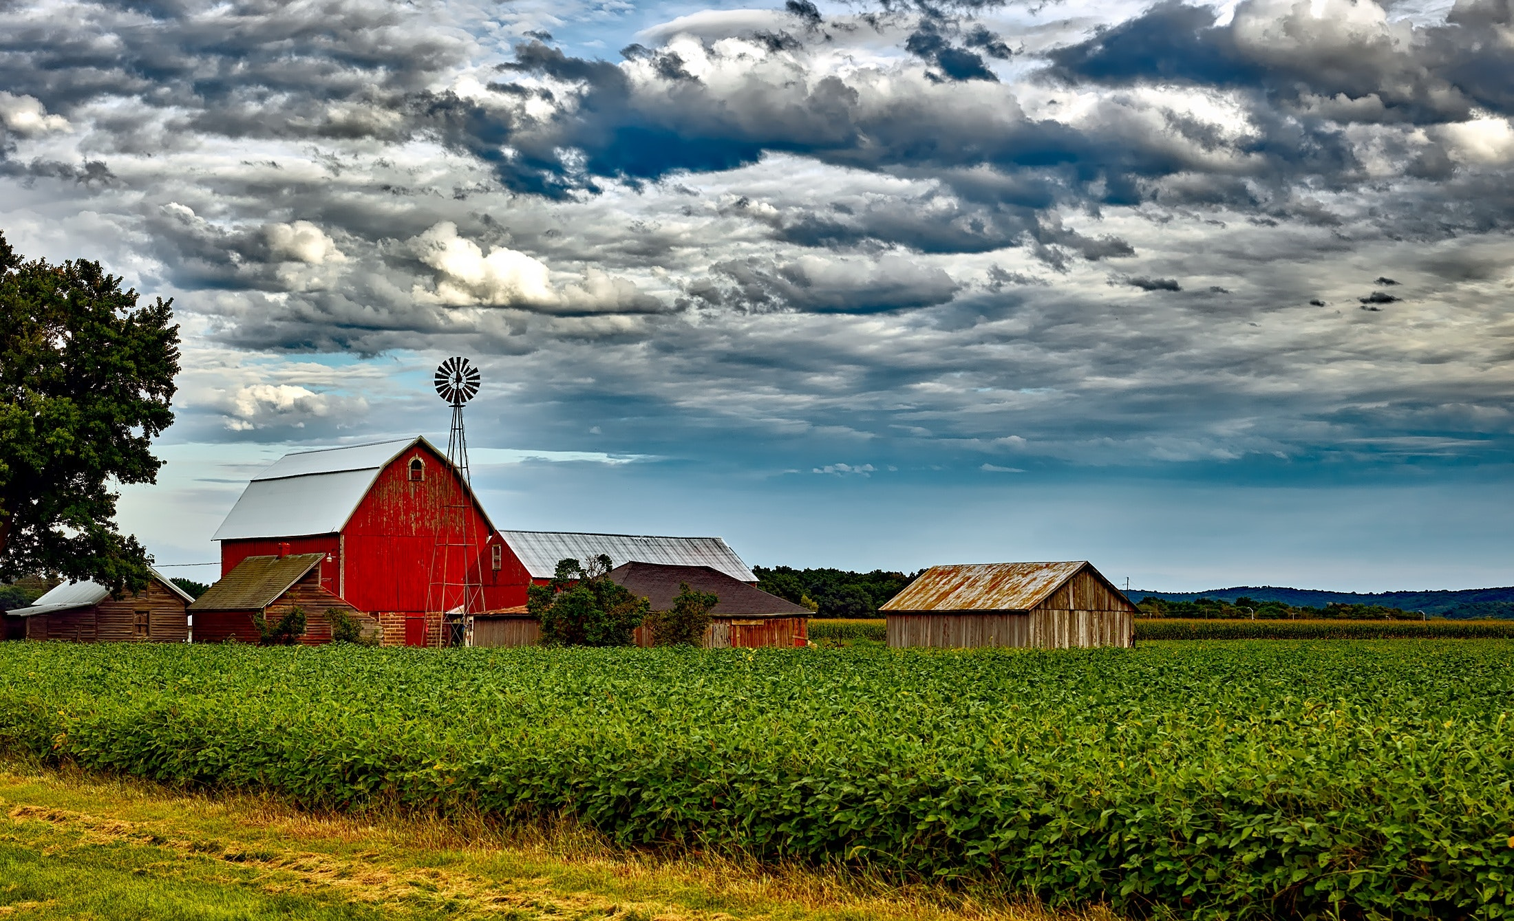

806-441-0723
angeecosta2016@gmail.com
1132 Copeland School Road
West Chester, PA 19380

ZILCH FARMS

PROPOSAL
Zilch Farms is planned as a diversified vegetable farm and agritourism operation owned and operated by Angee Costa, Michaela Linde, and Nikki Hinson. Zilch Farms is a new partnership between these operators. The intent is to operate the farm on leased land. This business plan will serve as an operating guide for Zilch Farms.

Why Zilch?

We named the farm Zilch to indicate our philosophy around food and farming. It represents:

- Zero waste
- Zero pesticides/herbicides
- Zero processing of animal products other than manure for fertilization.

Zero Waste

Zero waste is a method of sustainable farming that is growing in popularity. The reasons are simple. Using natural products results in “waste” that can be used elsewhere on the farm. Everything on the farm helps everything else. And since nothing is contaminated with pollutants, chemicals, or toxic fertilizers, it is safe to use again or transform into another use.

Plant waste can be composted. Compost is used to bolster the soil to help grow the vegetables. Chickens fertilize the soil and consume scraps. Composting worms produce rich castings that skyrocket growth, flavor, and nutrition. Herbs and ladybugs keep pests at bay. Chickens eat nuisance insects.

We farm with the Five R’s concept: refuse (we don’t bring plastics and other waste to the farm unless absolutely necessary); reduce; reuse; recycle; and rot (or compost). Nothing is wasted. It is a rich, clean, and highly functional ecosystem that is environmentally friendly.

The most important element to never waste is water. So, we prefer well water or rain catchment which are the best sources of moisture for the garden. Municipal water contains chlorine which prevents plants from efficiently gathering nutrients. Rainwater is also naturally pH balanced so that plants get exactly what they need for the sweetest taste.

Why Organic?

Zilch is committed to providing organic produce to consumers, restaurants, and retail outlets. Organic foods are packed with taste. Their complex flavor profiles are deep and intense. The difference is discernible from the very first bite. Healthy sugars infuse well-grown produce in ways chemical fertilization cannot match. But that’s not the most important part.

Organic foods offer beneficial micronutrients like vitamins, phytochemicals, and antioxidants that promote health and vitality. Additionally, organic foods help keep the environment free of harmful pesticides that contain chemicals and metals linked to a variety of diseases.

Organic is just better in every way. Plants grow strong and sweet. Their seeds are healthy and viable for saving and planting in subsequent seasons making Zilch a sustainable project for many years to come.

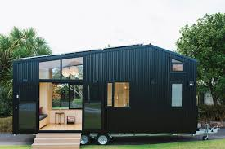
This tiny house on wheels is a sample of the house farm staff will live in. This house has two bedrooms and is fully self-contained.

In addition, we plan to install a new greenhouse for wash-pack infrastructure and season extension growing.

In addition, the crew plans to keep a small number of farm animals because they are beautiful and fun. No processing of animals will occur on the farm.
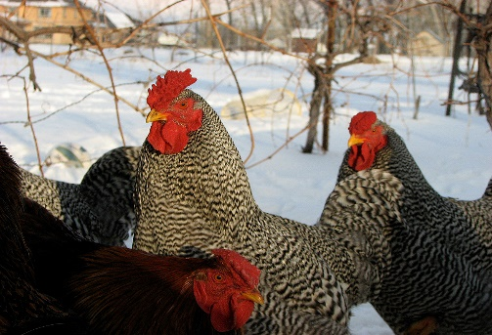
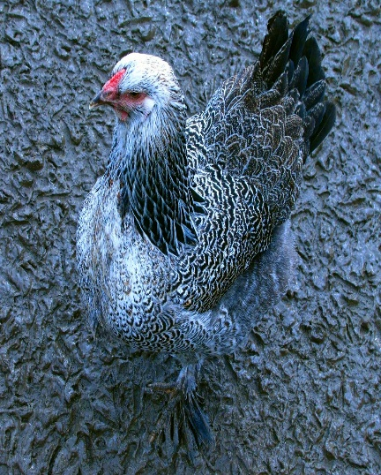
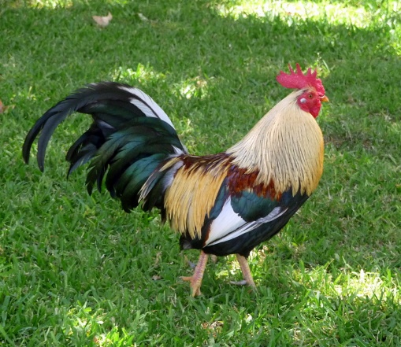

Zilch is committed to vegan farming. Our animals are never slaughtered. The focus of Zilch Farm in 2021 will be Heritage Chickens. Heritage breeds are disappearing at an alarming rate. They are different from factory chickens because they grow slowly and lay eggs sporadically. But these are some of the most beautiful breeds on earth. These birds feature gorgeous mop heads, fancy multicolored feathers, and brightly colored eggs. The eggs range from pink to purple to black. Heritage breeds are many times more efficient at foraging since it is part of their breeding. We will add in a handful of other animals as the cash flow and infrastructure allow.

Organic cash crop vegetables and cut flowers will be the foundation of Zilch Farm’s business in the 2021 season.

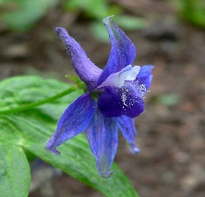
Lark Spur
This Photo by Unknown Author is licensed under CC BY-SA

Snapdragon

Peonies

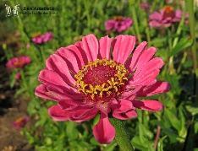
Giant Zinnias

Sunflowers

Mixed bouquets

Legal Ownership
The farm will be structured as an LLC with all operators as equal owners. Nikki will manage the agritourism side of the business, Michaela will oversee animal care and land management, and Angee will be responsible for crops and bookkeeping.

Crop Production

The most profitable cut flowers to grow include:

Beyond the standard suite of vegetables, including:
Cut Flowers
Lavender
Basil
Cilantro
Lettuces
Chives
Garlic
Corn

CSA MODEL

In addition to cash crops to sell at farmer’s markets, we intend to grow a variety of crops to supply a CSA group of customers. A CSA is a popular marketing channel as it provides monthly memberships that help in planning crop production. The market potential together with our marketing skills all align with the goal to grow a CSA membership base of 100 members by Phase III.

PHASE I | PHASE II | PHASE III
35 member CSA | 65 member CSA | 100 member CSA

The key to a successful CSA is variety of produce offerings to stave off buyer-fatigue that occurs when getting the same vegetables over and over. Zilch will offer a consistent quality, variety, and quantity of product throughout the
season.

Value added:
By offering CSA members more than they pay for, we provide opportunities to strengthen customer loyalty, retention, and referrals. We will offer:

- Recipes
- Flowers
- Nutrition cards
- Member appreciation events on the farm

Market Potential
With an impressive number of growing days, production timing and season extension strategies can provide 9-10 months of growing.

Communication with customers will be accomplished through a dedicated customer service phone line, Zilch’s website, and email.

Customers enjoy learning about the vegetables they buy. This is where Zilch Farm’s commitment to education is useful. We are willing to provide information about their vegetables and production methods to satisfy customers’ keen interest in where and how their food is grown. We have the aptitude and desire to create content for electronic newsletters and email updates, maintain the website and social networking with Nikki’s and Michaela’s background in graphics, social media, and web design. We are personable, enjoy talking to customers, and can provide excellent customer service.

Promotion/Marketing
Promotional efforts will target new customers interested in establishing a relationship with the farmer who is growing their food. Proximity is a critical factor for marketing a CSA in a rural community, and although there is
less in-season time required to market their CSA to new members, it does require intensive marketing time out-of-season (December – February).

Zilch will establish local key partnerships to help promote the business, such as local cafes and restaurants, the food co-op, and area businesses that support local farms and economies. Strategies include maintaining an online presence through the Zilch website and social media outlets, attending local events and fairs, selling at farmer’s markets, and word-of-mouth will all be employed to attract new members.

We find value in building relationships and loyalty with their members not only to maintain high retention rates, but also as an opportunity to build community connection. We wish to establish these relationships through personal or face-to-face customer channels.

In season, Zilch will continue to leverage marketing time by having customers pick up shares at the farmers market and farm stand where they will already be marketing additional products. We will host member appreciation events to help build a committed membership and direct connection to the farm.

Management
Angee has the bulk of experience in farm business management and diversified,
organic vegetable production having run a small market garden for three years in Pennsylvania and a small plot in Texas. She is skilled in crop planning, field and greenhouse production, cultivation, harvesting, and processing.

Nikki is a social media manager and digital editor with experience in creating websites and promotional videos.

Michaela is a skilled graphics designer and avid outdoors-woman with experience in handling animals.

Strengths
● 5+ years’ experience growing high-quality, organic vegetables
● Skilled at networking, advertising and making personal connections
● Financial Security with off-farm income and benefits

Opportunities
● Niche crops and value-added potential
● Exploring new wholesale markets

Threats
● Uncertainty with COVID impact

SAFETY
Zilch Farms will focus on efficiency and meeting local, state, and federal food safety regulations.

FARM PHILOSOPHY
- Farms should first be appealing to the eye, then to the palate.
- Find a market niche and diversify.
- Pursue highest dollar value per effort opportunities.
- Evaluate skills and focus on offering products and services in a way. that will maximize revenue in the short run and build the business and secure revenues in the long run.
- Establish strategic pricing strategies to maximize short- and long-term revenues, smooth cash flow, and create long-term relationships.
- Establish a “feedback loop” to evaluate how goods and services are received (solicit comments on quality, diversity and service).
- Never stop evaluating and adapting.
- Manage time well.
- Manage money to the penny.
- Utilize mentorship to minimize errors and maximize growth.

We are committed to ensuring professional and timely delivery of goods and services to clients while maximizing opportunities to build on good relationships.
Summarizing the strategic value/key components of our Financial Management Plan:
a. Establish budgeting, cash flow management, and bookkeeping procedures and follow them!
b. Include short-term, mid-term, and long-term needs in marketing plan, and budget for necessary technology and training
c. Update business plan, budgets, and cash flow projections monthly in Phase I and quarterly in Phases II and III.

Minimal impact to your land

Zilch’s farming processes and procedures mean the least impact to your land long-term:

- Raised bed farming instead of in-ground tilling

We will use permanent raised beds and other above-ground structures over your existing turf. So, when you need to have your land back, the beds can be easily disassembled, and the grass can return. Raised bed farming serves as a natural barrier to some pests.

- Movable structures instead of permanent infrastructure

We use raised beds and hoop greenhouses for easy set-up and tear-down.

- Natural pest control instead of pesticides

We never use RoundUp or Miracle Gro that create a heavy chemical load on the environment. We use natural pesticides, companion planting, and trap cropping.

- Well or Rain Water tables (or rain roof) instead of city water

Well water is great for crops. In the absence of a well, we can use a rainwater table to take advantage of the area’s higher than average rainfall. One inch of rain can produce as much as 27,000 gallons of water. The rain water table can collect 155 gallons of rain into 2-4 IBC totes producing up to 1,800 gallons of water.

- Composting bins

Compost is the safest and cleanest source of soil and fertilizer. Our bins contain only organic matter that does not attract pests or critters. As vegan farmers, we never use meat or other animal byproducts on our farm.

- Worm bins
Worm bins are one of our many secret weapons. Red wrigglers are quick and efficient composters. And they return rich casting to enrich the soil.

